Exercise 7-4 Object classification

Jirayu Petchhan, D10907801

From Main_Angular.py

Setting the method of cost function

Changing to object DS.

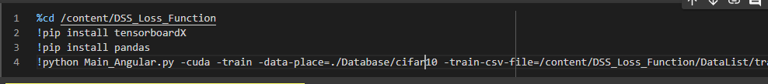

Default Loss (CE)

Performance

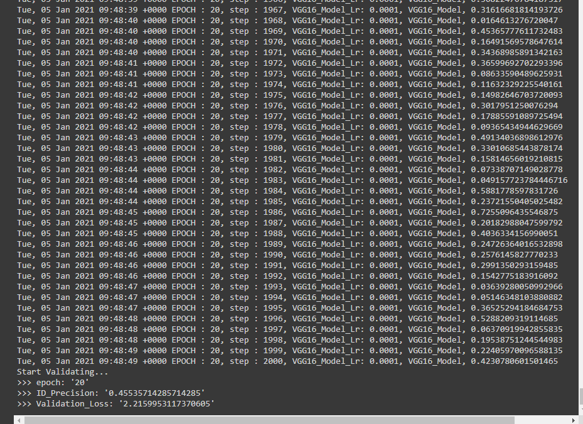

Changing to Angle Loss

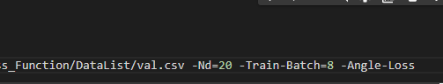

Performance

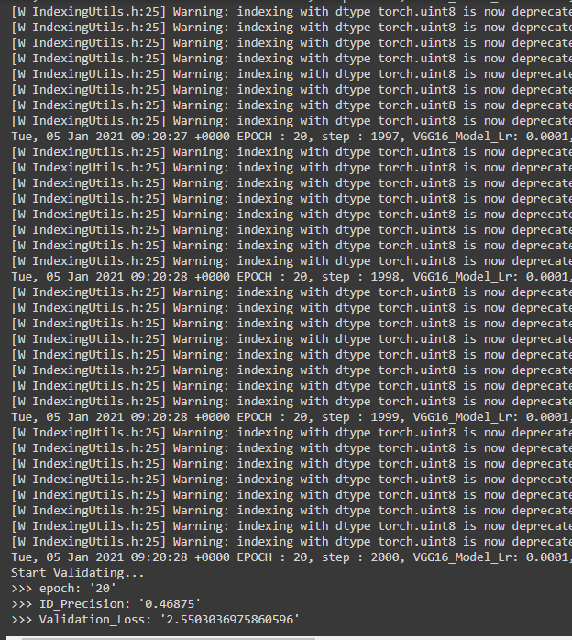

Result

The performance from CE loss is more effective than Angular Loss.

Snapshot path to use into feature compare



Feature comparation testing (based on Angle Loss) Nd=10 (10 classes for CIFAR10)

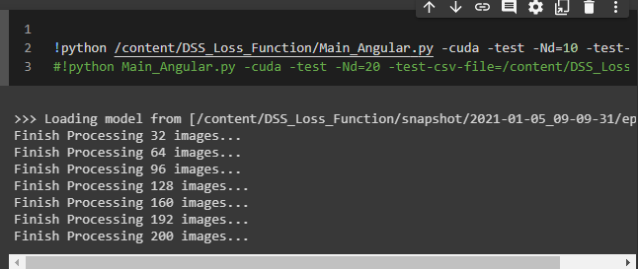

Changing output path for feature compare

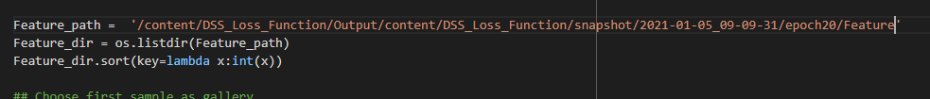

Accuracy from Euclidean method

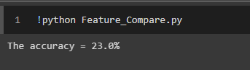

Accuracy from Cosine method

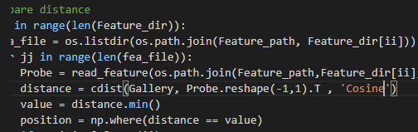

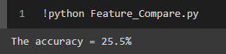

Result

The same as 7-2 and 7-3 that denote the Cosine method is a solution to make accuracy rather than the Euclidean method.